Oasis Central Minnesota Sponsorship Form
Name_____________________________________________________________
Address: __________________________________________________________________
City: ____________________________________State:__________________________
Phone Number: __________________ Email Address______________________

My donation is:
_____ $35.00 Individual Sponsorship
______ $70.00 Family Sponsorship
______ $100.00 Business Sponsorship
_______$200.00 Sustaining Sponsor

_____YES! I am interested in more information on volunteer opportunities with Oasis Central Minnesota.
_____ YES! I am interested in more information on Board and Committee involvement.
_____ YES! Please save a tree and a stamp and send me my newsletters via email.

Please make checks payable to: Oasis Central Minnesota
Please complete this form and mail with payment to:
Oasis Central Minnesota, PO Box 542, Little Falls, MN 56345
Oasis Central Minnesota is a 501(c)3 organization. All donations are tax deductible.
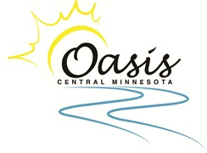
Building Community by Working Together!

