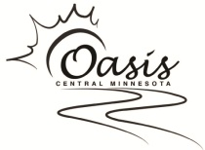
Oasis Central Minnesota
Sponsorship Form

Name______________________________________________________
□Personal Donation □Business Donation
Street Address_______________________________________________
City_________________________State________Zip________________
Phone Number______________________________________________
Email Address_______________________________________________
Please complete this form and mail with payment to:
Oasis Central Minnesota, PO Box 542, Little Falls, MN 56345
320.632.9140 • oasiscm@live.com • www.oasiscm.org
Thank you for your generous support!
□ Individual = $35.00
□ Family = $70.00
□ Sustaining = $125.00
□ Sponsorship = $250.00 +
□ Other ___________________
Please make checks payable to: Oasis Central Minnesota
Oasis Central Minnesota is a 501(c)3 organization.
All donations are tax deductible.
Building Community by Working Together

